|  |
| --- |
| 新东方在线英语学习 |
| 新概念 3 册 |
| Lesson4 |



扫一扫。更多有趣的英语资讯。

# Lesson 4 The double life of Alfred Bloggs

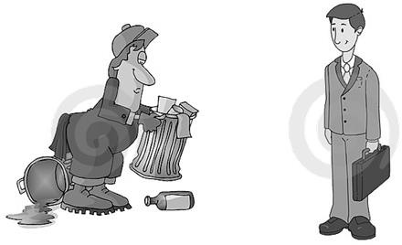

**manual ['mænjuəl] adj. 体力的**

manual work / labor

反义：mental or spiritual? mental work / labor

spiritual material “man(u)” = hand manufacture

biscuit manufacturers soap manufacturers

Manacle

manuscript

emancipate

emancipate slaves

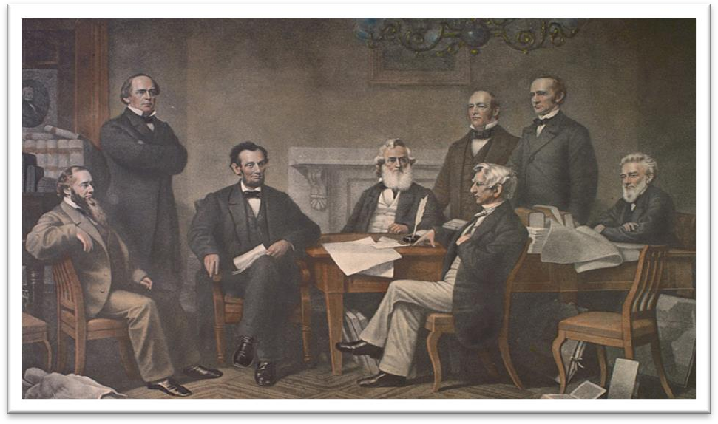the emancipation of women the Emancipation Proclamation

# collar ['kɒlə(r)]

**n. 衣领**

Hi, buddy! much

I love you, honey.

color

The color of the collar is white.

white-collar workers

blue-collar workers

The policeman collared the thief.

tie

tie a tie

sigh a sigh

wish a wish

I wished a wish on the star. dream a dream

die a glorious death

breathe one’s last breath

# sacrifice ['sækrɪfaɪs]

**v. 牺牲，献出**

sacrifice … for …

Many women sacrifice their careers for their families.

Such is human nature, that a great many people are often willing to sacrifice higher pay for the privilege of becoming white-collar workers.

Relatively few people are prepared to sacrifice holiday time for the pleasure of travelling by sea.

give up

abandon

abandon ship

renounce

renounce smoking and drinking

cede

Hong Kong was ceded to Britain after the Opium War.

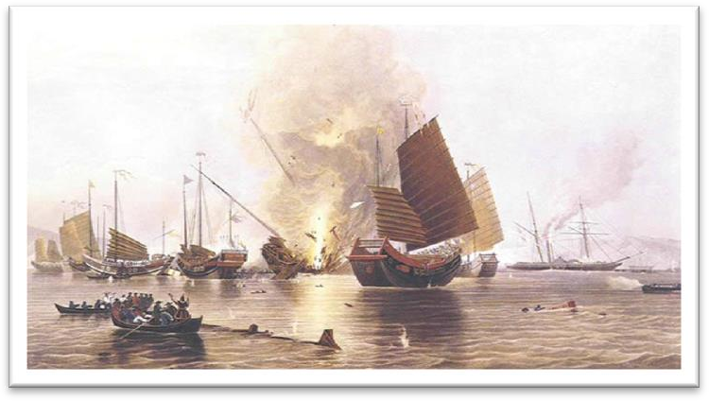

# privilege ['prɪvəlɪdʒ]

**n. 特权，特殊的好处**

enjoy a privilege

abuse a privilege

Education is a right, not a privilege.

have the privilege to do …

Today, I have the privilege to speak at this important international forum on behalf of the Chinese

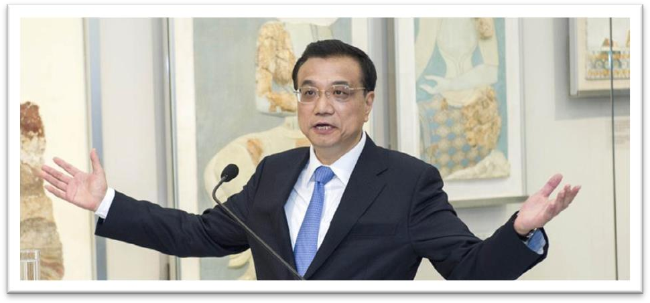government.

# corporation [kɔ:pə'reɪʃn]

**n. 公司**

multinational corporation company firm

business concern

enterprise

foreign funded enterprise joint-venture enterprise

state-owned enterprise (SOE) private enterprise

township enterprise

These days, people who do manual work often receive far more money *than people who work in offices*.

these days

today

Now a days

in those days

In those days, boxers fought with bare fists for prize money.

In those days wandering minstrels were welcome everywhere.

receive money

make money

earn money

far / much / even / still / yet … slightly / a little / a bit …

造句：现如今，在娱乐界 (the entertainment field) 工作的人挣的钱往往比在教育行业 (the education sector) 工作的人多得多。

These days, people who work in the entertainment field often receive far more money than people who toil in the education sector.

People who work in offices are frequently referred to as ‘white-collar workers’ *for the simple reason that they usually wear a collar and tie to go to work*.

# anadiplosis 顶真；连珠

一生二 二生三 三生万物地法天 天法道 道法自然

天下文章数三江 三江文章数鄙乡鄙乡文章数进士 进士跟我学文章

Our grief has turned to anger, and anger to resolution.

For glances beget ogles, ogles sighs, sighs wishes, wishes words, and words a letter. If you dream it, you can do it;

if you do it, you can love it;

if you love it, you can enjoy it; if you enjoy it, you can make it.

refer to …: 提到……; 谈及……= mention … / speak of …

Please don’t refer to this matter again.

refer to A as B

call A B

… and others will call him ‘Mr. Bloggs’, not Alf.

address A as B

Elizabeth: This is my father, Paul Stevens. Dad, this is Ross Geller. Ross: It’s great to meet you Paul.

Paul: I usually prefer Elizabeth’s boyfriends to address me as Mr. Stevens. Ross: Of course, of course, Mr. Stevens.

know A as B

He soon made a name for himself and came to be known to the Italians as Giovanni Acuto.

Because of this, they were known as ‘prizefighters’.

He was known to us all as Dickie and his eccentricity had become legendary long before

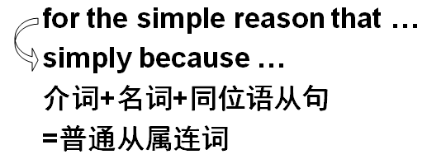

he died.

for the reason that …

because of the fact that …

due to the fact that …

on account of the fact that …

= because …

in spite of the fact that … despite the fact that …

= although …

Despite the fact that the bottle is tinted a delicate shade of green, an observant visitor would soon notice that it is filled with what looks like a thick, grayish substance.

造句：大熊猫常常被称为活化石 (living fossil)，只不过因为它们在世界上已经生存了两亿多年了。

Giant pandas are frequently referred to as ‘living fossils’ for the simple reason that they have lived on earth for over 200 million years.

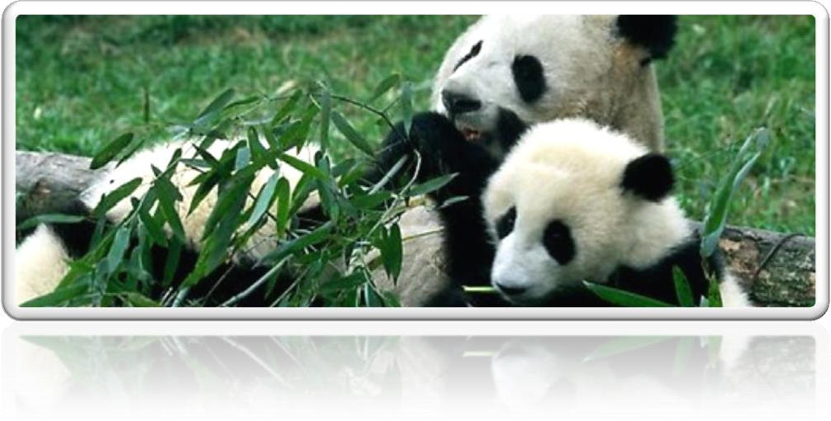

Such is human nature, that a great many people are often willing to sacrifice higher pay *for the privilege of becoming white-collar workers*.

nature n. 本性、天性

Excuse me, nature calls.

He is kind by nature.

Such is human nature that …

It is human nature that …

Such is human nature that we all love to get something for nothing.

Such is human nature that we don’t treasure what we have until we lose it. Human nature is such that a great many people …

The conditions of society are such that skills have to be paid for in the same way that goods are paid for at a shop.

Such are the conditions of society that skills have to be paid for in the same way that goods are paid for at a shop.

be willing to do

I shook my head and held up five fingers indicating that I was willing to pay ￡5.

be ready to do

If your order is large enough we are ready to reduce our prices by 5%.

be prepared to do

Why people are prepared to tolerate a four-hour journey each day for the dubious privilege of living in the country is beyond me.

be unwilling to do be reluctant to do

Though he was reluctant to do so at first, we eventually persuaded him to take us.

for the privilege of …

Why people are prepared to tolerate a four-hour journey each day for the dubious privilege of living in the country is beyond me.

This can give rise to curious situations, as it did in the case of Alfred Bloggs who worked as a

dustman for the Ellesmere Corporation.

give rise to sth. (fml.) 导致……

The president’s absence gave rise to speculations about his health.

cause effect result in

bring about lead to

contribute to

account for

in the case of ...

in case of ...

in the event of ...

In case of / In the event of bad weather, the wedding will be held indoors.

I work as an English teacher for New Oriental School.

Thank you very much for having offered me such a golden opportunity to work as an editor for Designs & Fashions, a best-selling magazine renowned for its extraordinary quality and taste. 观点+例证

….（观点）,

as it did / does in the case of … who …

This can cause curious situations. Alfred Bloggs was an example. He worked …

造句: 压力 (stress) 会导致精神上的一些疾病 (mental diseases), 正如在通用汽车公司

(General Motors) 工作的工程师 Mike Johnson 身上发生的情况一样。

Stress can give rise to mental diseases, as it did in the case of Mike Johnson who worked as an engineer for General Motors.

get married

marry sb.

be married to sb.

The girl was married to me.

The girl was engaged to me.

be (dressed) in …

He was (dressed) in a smart black suit.

sb. wear sth.

He left home wearing a smart black suit.

Suit

1. Take a lot of money.
2. Go to a different restaurant.
3. Don't invite John.
4. Wear different clothes.

W: I'm taking John to that fancy new restaurant tonight. M: You can't go like that. You'd better change.

Q: What does the man advise? Answer: (D) Wear different clothes. change (out of…) (into …)

You’d better change out of the red jacket into a blue one.

spend … on sth. / (in) doing

I spent a lot of money on food.

I spent a lot of time on homework.

I spent a lot of time (in) learning English.

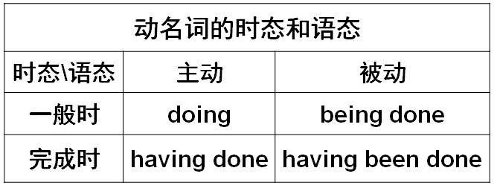I spent my summer vacation in Hainan Province.

I treasured every minute I spent with your family.

After gazing at the display for several minutes, Mr. Taylor went back into his shop.

Four days after setting out, while the Titanic was sailing across the icy waters of the North Atlantic, a huge iceberg was suddenly spotted by a look-out.

Ashamed of having acted so rashly, Dimitri apologized to Aleko for having accused him.

Pretending to speak seriously, one of the workmen asked if he might make a telephone call before being taken to the station.

After having been wounded towards the end of the war, he had been sent to hospital and was separated from his unit.

fellow dustmen fellow actors fellow students fellow citizens

fellow Chinese / Americans …

The gaoler looked on eagerly, anxious to see if his fellow actor had at last learnt his lines.

In so far as any inquiry is a secret one, it naturally limits all those engaged in carrying it out from effective contact with their fellow scientists either in other countries or in universities, or even, often enough, in other departments of the same firm.

We would lay less stress on 'facts and figures' and more on a good memory, on applied psychology, and on the capacity of a man to get along with his fellow citizens.

And so, my fellow Americans, ask not what your country can do for you; ask what you can do for your country.

— John F. Kennedy workmate

Colleague

associate

One night, the gaoler decided to play a joke on his colleague to find out if, after so many performances, he had managed to learn the contents of the letter by heart.

Alf's wife has never discovered that she married a dustman and she never will, *for Alf has just found another job*.

我过去是，现在是，将来也会是你的朋友。

I was, am and will be your friend.

will be doing 表达一种可预见性

Professor Wang will be taking charge of our department next Monday.

He will be earning only half as much as he used to, but he feels *that his rise in status is well worth the loss of money*.

He will be earning only half as much as he used to (earn), …

英语中表达倍数的三种方式

1. A is … times as … as B
2. A is … times the amount (the number, the size, the length, the width/breadth, the height, the value, the price, etc.) of B
3. A is … times 比较级 than B

# 他的工资是我的三倍。

His salary is three times as much as mine.

His salary is three times the amount of mine.

His salary is twice more than mine.

# 这个箱子是那个箱子四倍大。

The box is four times as big as that one. The box is four times the size of that one.

The box is three times bigger than that one.

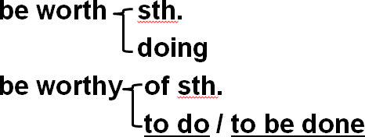



The day when Beijing won the right to host the 2008 Olympic Games is worth being celebrated. X The day when Beijing won the right to host the 2008 Olympic Games is worth celebration / celebrating. √

The day when Beijing won the right to host the 2008 Olympic Games is worthy of celebration / to be celebrated. √

call sb. names

Stop calling my father names!

